Project Design Phase-II
Data Flow Diagram & User Stories

Date | 06/03/2026
Team ID | SWTID-2026-2469
Project Name | Contact Manager
Maximum Marks | 4 Marks

Data Flow Diagrams:

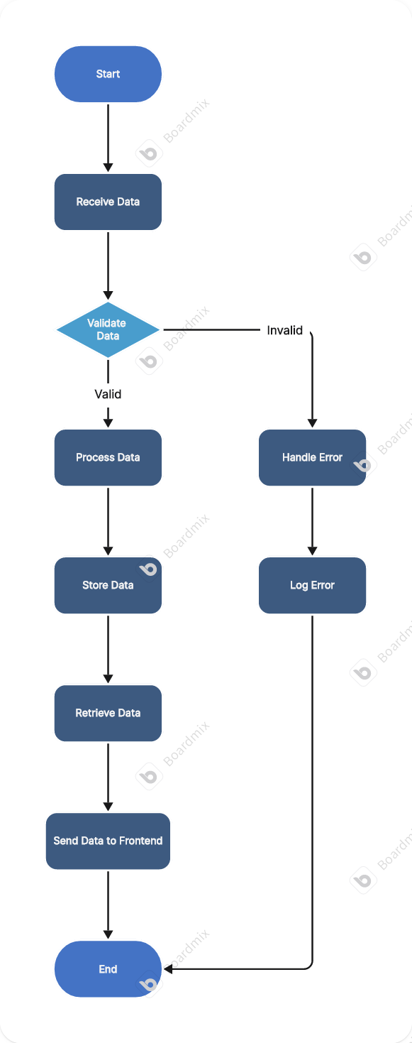

User Stories

User Type | User Story Number | User Story / Task | Acceptance criteria | Priority | Release
Student | USN 1 | As a user i can add and update the contacts ant any time | Fast addition and update | High | Sprint 1
Developer | USN 2 | As a user i can search for the contacts fast | Fast search results | High | Sprint 1
Manager | USN 3 | As a user i can view the contacts of my team and update them as required | Fast update and fetch | High | Sprint 2

